Final Report

1. **Research Question:** How have the linguistic patterns and thematic emphases in climate change debates differed between the Republican and Democratic parties in Congress from 2001-2010, and how have these differences evolved over time?
2. **Hypothesis:**
3. Initial hypothesis: There was a clear dichotomy in the U.S. approach to environmental issues, significantly influencing climate change debates' linguistic patterns and thematic emphases, and the two parties diverged more. Patrick Allitt (2015) discusses the pivotal role of Bush's presidency in shaping the discourse on environmental policy. Allitt suggests that during Bush's tenure, the environmental debates in Congress and among the public grew significantly more polarized.
4. History context: From 2001 to 2005, Democrats primarily emphasized the urgency of addressing climate change due to its potentially catastrophic impacts on global environments and economies. They framed it as a critical and immediate issue that necessitated substantial policy action, focusing on proactive measures to curb emissions and promote alternative energy sources. Post-2005, Democrats shifted their approach by integrating discussions of climate change with economic opportunities, emphasizing green jobs and the economic benefits of transitioning to renewable energy. This alignment of environmental policies with economic growth involved a more detailed discussion of the economic and social benefits of addressing climate change. On the Republican side, from 2001 to 2005, there was a tendency to question the science behind climate change or to downplay its impacts, focusing on the economic risks of stringent environmental regulations. Republicans argued that such policies could hinder economic growth and competitiveness. After 2005, although there was a slight shift towards acknowledging the need for some form of action on climate change, the emphasis remained on the potential economic drawbacks. Some Republicans began to support limited environmental measures, especially if they were market-based solutions or could be shown not to harm the economy, though skepticism about climate science persisted. These changes reflect broader shifts in political and public perceptions of climate change, where economic factors increasingly influence environmental policy discussions. This evolution in discourse also mirrors the growing polarization in American politics, where environmental issues have become intertwined with party identities and ideologies.

**3. Method:**

(a) Analyze Congress speeches from the "hein-daily" file provided by Stanford Congress data, which includes daily records from 2001 to 2010. Files like 'speakermap', 'descr', and 'speech', are converted from text to CSV format and then merged to form a consolidated dataset.

(b) Rreprocessing: the text is converted to lowercase, stopwords are removed to filter out uninformative words, and unnecessary columns are dropped.

(c) Apply the BERTopic model to the entire corpus to identify themes (Figure 1). After generating 200 topics, those relevant to climate, climate change, and environmental issues are selected for further analysis.

Concepts: BERTopic is a topic modeling technique that leverages transformer-based models (like BERT) along with clustering algorithms to identify topics within textual data. For this study, BERTopic is applied to a large dataset of political speeches, generating 200 topics to provide a comprehensive overview of the discourse landscape over a decade.

Additionally, its use of contextual embeddings is crucial for accurately interpreting political rhetoric, where the context can significantly alter word meanings. Furthermore, BERTopic employs hierarchical clustering to group similar topics, facilitating the aggregation of related themes into broader categories. This aids in identifying overarching themes and provides a structured representation of how specific topics interrelate, offering a clear and organized view of the data.

(d) Next, segment the corpus into two subset datasets based on party affiliation, designated 'D' for Democrats and 'R' for Republicans, as indicated in the 'party' column. The LDA model was employed on these subsets to delve deeper into how each party discusses climate and environmental issues. By extracting the top 10 topics from each subset, LDA provides a structured basis for directly comparing the dominant themes in Republican and Democrat discussions. This approach aids in precisely identifying differences in thematic emphasis between the two parties. Compared to BERTopic, LDA is more conducive to tracking changes over time within each subset. Applying LDA to speeches from different years or periods allows for effective visualization and analysis of how key topics evolve, offering insights into shifting priorities and changes in rhetoric. Visualizing these topic changes over time enhances understanding of how discourse adapts to new information, external events, or shifts in policy focus. It also illustrates the evolution of party-specific concerns and priorities regarding climate change and environmental issues.

Figure 2 and Figure 3 are for Democrats, and Figure 2 is a stacked bar chart representing the average topic weight for each year. Each color represents a different topic. Some topics like "Climate Change Policy," and topics about energy consistently occupy significant portions of the discussion each year. Other topics show more fluctuation from year to year. For instance, "National Parks and Historic Preservation" and "Coastal and Disaster Management" vary in their weight, suggesting changes in focus possibly due to events or shifts in policy priorities. To more clearly observe changes over time in the thematic emphasis of political discourse, a second visualization (Figure 3), a line chart depicting the average topic weight over time, was introduced. This chart allows for the identification of trends and fluctuations in the importance of specific topics within the discourse. Certain topics exhibit significant changes during specific periods. Notably, the topic of "Coastal and Disaster Management" shows a marked spike around 2005, which can be associated with the impact of natural disasters such as Hurricane Katrina. This spike indicates an increased urgency in discussions about natural disaster management. The catastrophic impact of Hurricane Katrina, one of the most expensive disasters in the history of the insurance industry, along with subsequent storms like Rita and Wilma, underscored several fundamental flaws in hurricane management (Mahalingam et al., 2018). These events revealed inept disaster responses and inefficiencies in the administration of aid, exacerbating the discourse on disaster management strategies. Other topics demonstrate a consistent increase in emphasis over the decade. For example, the topic "Energy Markets and Drilling" displays a general upward trajectory, reflecting its growing prominence. This increase may be attributed to factors such as rising energy prices or intensifying debates over drilling policies, which have gained greater salience in political and public discourse.

Figure 4, a stacked bar chart for the Republicans, highlights a balanced distribution of focus on various topics over the years, suggesting a diverse range of concerns addressed by Republicans. Topics like "Energy Policy and Legislation" and "Land Management and Federal Policy" also maintain a consistent presence over the years, indicating their perennial significance within the party's policy discussions. The topic "Environmental Disasters and Response" exhibits noticeable fluctuations in importance, likely corresponding to real-world environmental events that prompted shifts in discourse emphasis. For Figure 5, The topic "Energy Strategy and Resources" shows a sharp increase in 2008, suggesting a pivotal discussion or event influenced this spike. This increase could be linked to several factors, including the 2008 financial crisis, which had profound impacts on energy investments and market dynamics. The economic downturn led to significant shifts in energy policy discussions, possibly reflecting the heightened discourse on energy strategies during this period. Specifically, in response to the financial crisis, the Federal Reserve significantly lowered federal fund rates, which directly impacted the depreciation of the dollar and the rise in oil prices (Taylor, 2009). This economic backdrop likely contributed to the 2008 spike in discussions related to energy strategy. The topic "Energy Policy and Legislation" shows an increasing trend towards the end of the decade, paralleling the growing urgency and restructuring of energy policies nationally and globally. This trend may also reflect broader political and economic concerns surrounding energy independence and sustainability.

These charts suggest that the Republican Party's focus on various climate change-related topics has evolved and responded to a mix of policy initiatives, environmental events, and economic contexts. There are spikes and dips in attention to different topics, indicative of the changing priorities and responses to the current events of the respective years. This illustrates how external economic shocks, such as the 2008 financial crisis, can influence political discourse and policy priorities, particularly in sectors sensitive to economic fluctuations like energy.

(e) Similarity: To analyze the similarities in political discourse between the Democratic and Republican parties, this study utilizes TF-IDF vectorization and Cosine Similarity calculations. Initially, speeches are structured using TF-IDF, which highlights the uniqueness of terms by adjusting the weight of words based on their document frequency, thus differentiating the content between parties. Cosine Similarity then quantifies the similarity between the TF-IDF vectors of the speeches, with a score of 1 indicating identical content and 0 indicating no similarity.

The similarities are computed annually to identify periods of convergence or divergence in rhetoric, which reflects how each party's discourse responds to events or shifts in policy. These computed similarities are visualized and stored in dictionaries by period for analysis. Significant findings include the highest textual similarity in 2003 and the lowest in 2009 (Figure 6), prompting a further KWIC analysis. This analysis examines the context of keywords to understand shifts in themes and issues over time, revealing how external events and political dynamics influence party rhetoric. KWIC helps elucidate the dynamics of political language and its evolution, offering insights into the changing political landscape.

(f) KWIC: The Key Word in Context (KWIC) analysis for the years 2003 and 2009, which focuses on the keyword "energy," provides a fascinating insight into the evolution of political discourse between these years. Despite both years concentrating on "energy," 2003 is the year with the highest textual similarity between the Democratic and Republican speeches, while 2009 is the year with the least similarity. The constant focus on "energy" over these years, despite diverging political discourse, suggests that while both parties deemed energy a crucial topic, their approaches or solutions likely diverged significantly by 2009. In 2003, the closer alignment might indicate a period of shared concerns about energy policies. By 2009, the drastically reduced similarity suggests that new factors had influenced the parties' stances, leading to a broader disparity in how they addressed energy issues.

(g) Collocation Words (Inspect the data for ‘energy’ at different moments): To deepen the understanding of the term "energy" within political discourse, this study utilizes a collocation analysis method. The method involves selecting and examining speeches from both Democrats and Republicans in the years 2003 and 2009 that prominently feature the word “energy.”

Figures 7 and 8 highlight excerpts from speeches by Democrats and Republicans in 2003, where "energy" was mentioned frequently. The Democratic and Republican parties recognized the importance of addressing the country's energy challenges, their approaches were marked by differing emphases and priorities, reflecting their respective political ideologies. However, despite these differences, speeches from both parties frequently mentioned climate change as a significant factor of energy policy and acknowledged the environmental impacts associated with energy production, particularly from fossil fuels. This consensus underscores a period where bipartisan approaches to energy policy were somewhat prominent, indicating a shared urgency in addressing both energy and environmental concerns. The acknowledgment of these issues across party lines during this year emphasizes a collective recognition of energy production, environmental health, and economic stability.

Figures 9 and 10 are excerpts from speeches by the two parties in 2009. The discussion on energy policy between the two parties highlighted significant ideological divergence on climate change, economic implications, and approaches to energy. Republicans strongly opposed President Obama’s energy initiatives in 2009, particularly criticizing the cap-and-trade system as an economically detrimental tax. They supported enhancing domestic production of traditional energy sources like oil, gas, and nuclear energy, aiming to achieve energy independence and economic growth. Concerns were raised about the economic burdens imposed by renewable portfolio standards, especially on states with limited renewable resources. In contrast, Democrats emphasized the severe economic and environmental repercussions of continued oil dependence and advocated for a shift away from traditional energy practices. They supported legislative efforts to reduce oil consumption and address the associated risks, focusing on transitioning towards sustainable and renewable energy sources.

(h) Collocation Analysis: Next, the analysis focus on the frequency of the word "energy" in conjunction with other terms within the corpus, leading to the compilation of two distinct word lists for the Democrats (D) and Republicans (R). This exploration reveals unique lexical preferences between the parties: terms such as "tax," "nuclear," and "job" were predominantly featured in the Republican context, whereas "efficiency" and "technology" were more frequently associated with the Democrats. These findings highlight the differing emphases and concerns regarding energy within each party's discourse.

For the Republicans, Figure 11 displays a focus on "gas," "tax," "nuclear," and "job" alongside "energy." There was a significant spike in mentions of "gas" in 2008, reflecting concerns over energy security and fossil fuel dependence during a period of high oil prices. Discussions often revolved around "tax," suggesting debates on energy tax policies, such as incentives or rebates for energy production. "Nuclear" indicates a sustained interest in nuclear energy as a potential solution to energy needs. The mention of "job" underscores the economic implications of energy policies, highlighting the Republicans' focus on traditional energy sectors as critical drivers of job creation and economic stability.

For the Democrats, Figure 12 shows "technology," "oil," "renewable," and "efficiency" as key collocates with "energy." The spike in "oil" in 2008 reflects concerns similar to those of the Republicans, driven by the global oil price crisis. The consistent mentions of "renewable" and "efficiency" from the mid-decade onwards highlight a growing commitment to sustainable energy sources and energy efficiency, underscoring a cornerstone of Democratic energy policy. The rise in "technology" mentions suggests an emphasis on technological innovation in energy as a pathway to addressing climate change and energy sustainability.

**4.Finding and Conclusion:**

The research on U.S. energy policy discourse in the late 2000s provides a complicated understanding of how the two parties diverged, particularly in the context of the 2007-2008 financial crisis. Republicans, emphasizing economic growth and energy independence, strongly advocated for the expansion of domestic oil and gas production. They supported this approach due to the substantial economic benefits of the oil and gas industry, such as job creation and reducing the trade deficit. Traditional energy sources were promoted as a strategy to maintain low consumer energy costs and bolster national security. Democrats shifted their focus toward sustainable energy sources, significantly emphasizing technology and renewable resources. From the mid-decade onwards, the party increasingly highlighted "renewable" and "efficiency," viewing these elements not only as crucial for environmental responsibility but also as vital for future economic competitiveness and sustainability. This strategic pivot was framed as essential for addressing the long-term environmental challenges posed by traditional energy sources and the economic instability associated with fossil fuel dependency.

The 2007-2008 financial crisis intensified these ideological differences, impacting the energy policy debates profoundly. Republicans focused on immediate economic recovery measures, advocating for increased production of traditional energy sources which they believed would provide quick solutions to economic downturns and job losses. Conversely, Democrats advocated for a transformation in energy consumption patterns toward renewable sources, arguing that this would provide more sustainable economic and environmental benefits.

This period of intense divergence contrasted with earlier instances of more bipartisan approaches, notably in 2003. Despite Patrick Allitt’s observations of increased polarization during Bush's presidency, the analysis revealed a somewhat prominent bipartisan consensus in the early 2000s. Both parties recognized the economic implications of energy dependency and the environmental damages associated with traditional energy production, fostering mutual support for reducing foreign oil dependence and addressing environmental issues. This early cooperation was facilitated by shared concerns over national energy security, prompted by events like the 2001 energy crisis and heightened geopolitical tensions in oil-rich regions.

In conclusion, while the initial hypothesis anticipated a clear dichotomy and increasing polarization, the discourse revealed more complicated dynamics. Particularly in the early 2000s, there were moments of bipartisan consensus on energy policy, as both parties recognized shared concerns over energy security and the economic and environmental impacts of energy dependency. Political parties frame their environmental and energy policies to align with their broader ideological stances. Politicians leverage specific linguistic techniques such as catchy phrases, simplified language, and strategic framing to resonate with broad audiences and influence public opinion (Luu, 2018). Republicans, for instance, emphasize traditional energy sources as essential for national security and economic stability, employing terms like "job creation" and "energy independence" to appeal to economic preservation interests. In contrast, Democrats advocate for renewable energy through language that stresses long-term sustainability, innovation, and moral responsibility, using phrases like "sustainable development" and "clean energy" to evoke a sense of urgency about environmental emergency. The strategic use of language is important in reflecting ideological bases persuading the public and shaping policy outcomes (Luu, 2018). The linguistic divergence between the parties was notably sharpened by the economic context of the 2007-2008 financial crisis. Republicans emphasized the immediate economic benefits of deregulation and tax relief. At the same time, Democrats highlighted the long-term benefits of investments in green technology and jobs, reflecting their respective approaches to economic recovery and sustainability.

It is crucial to understand the evolving discourse on climate change and energy policy. This analysis focuses on the complex interplay of economic stability, environmental sustainability, and national security interests within U.S. energy policy, all shaped by broader political and economic agendas.

Figure 1:

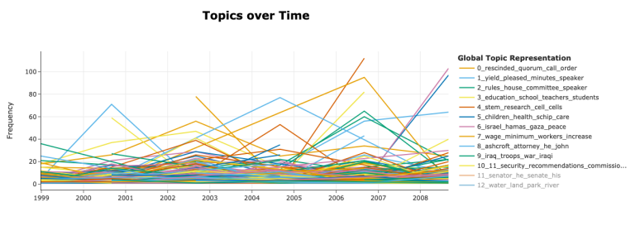

Figure 2: Figure 3:

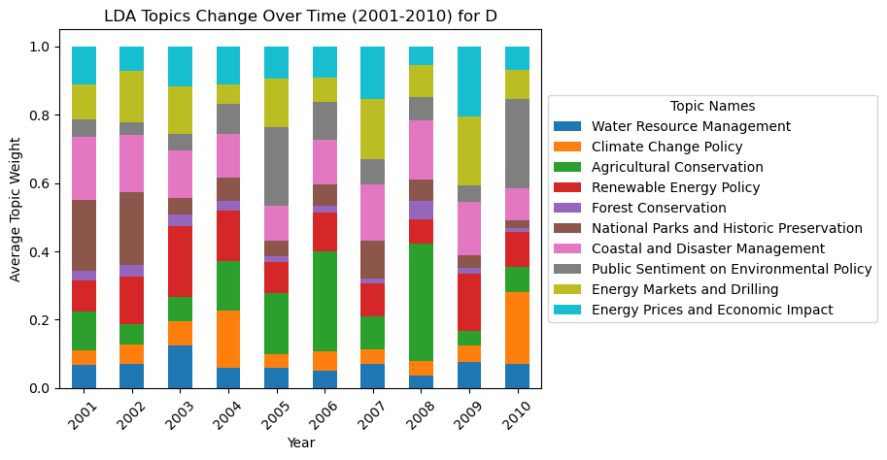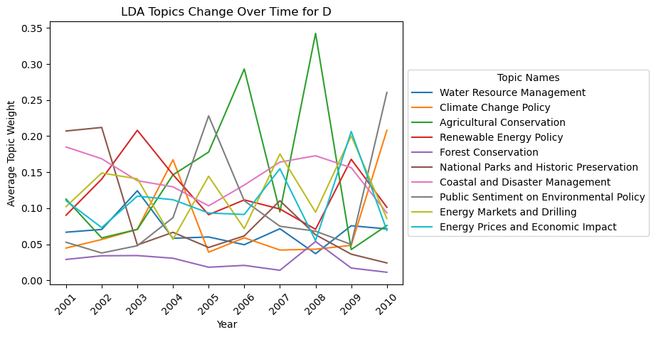

Figure 4: Figure 5:

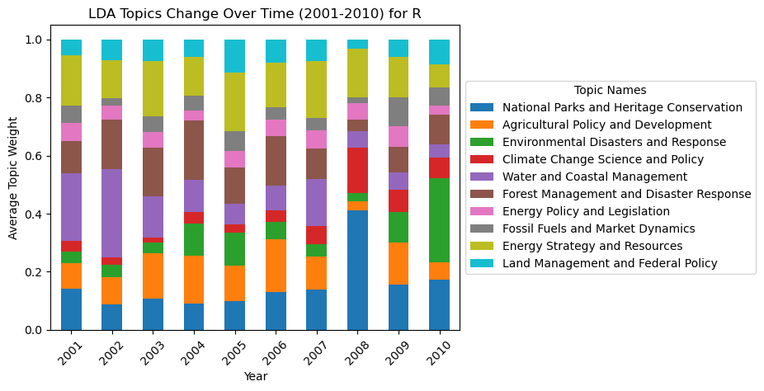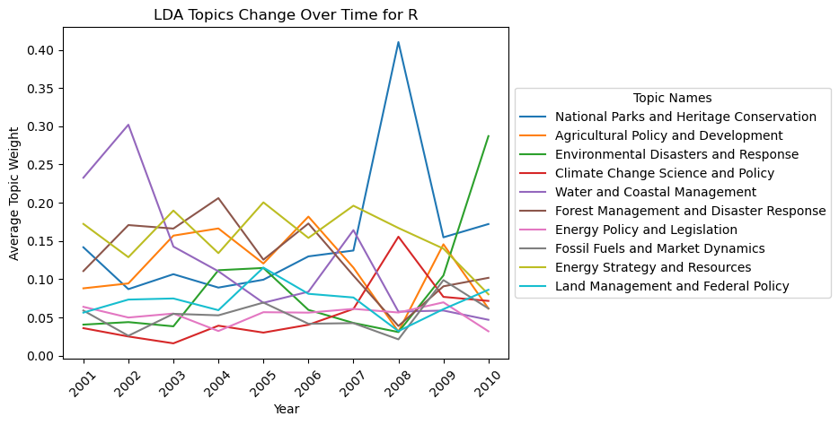

Figure 6:

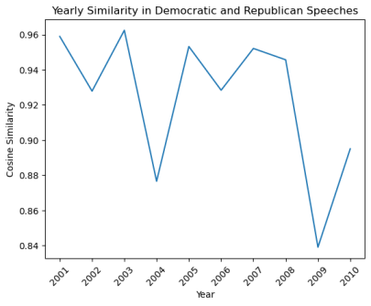

Figure 7: Figure 8:

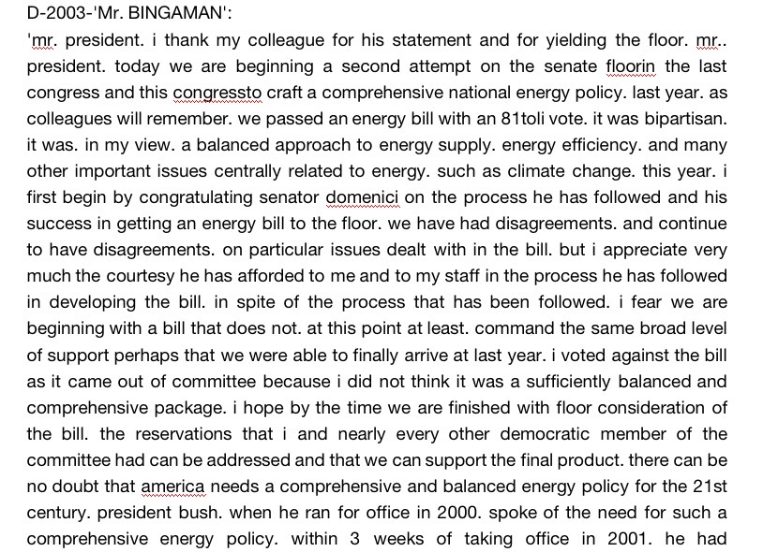 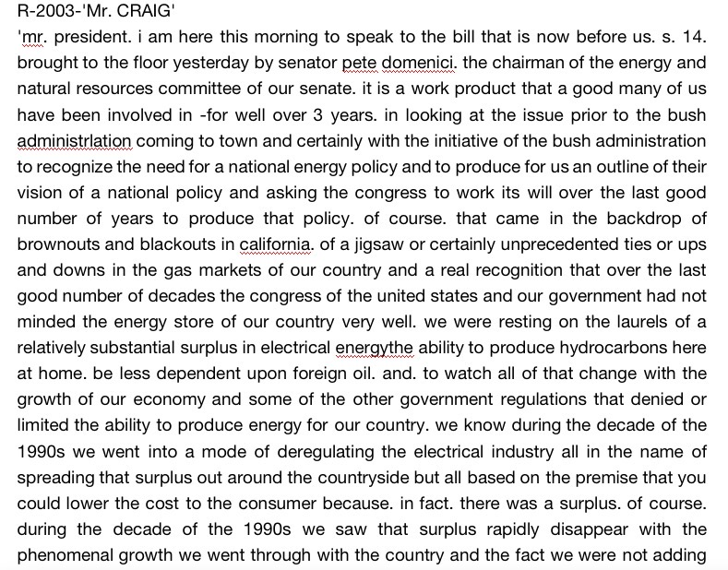

Figure 9: Figure 10:

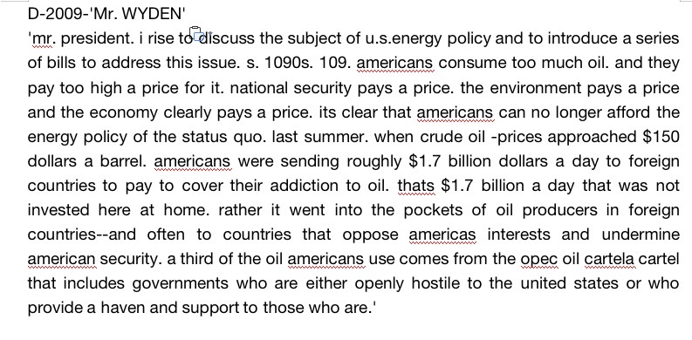 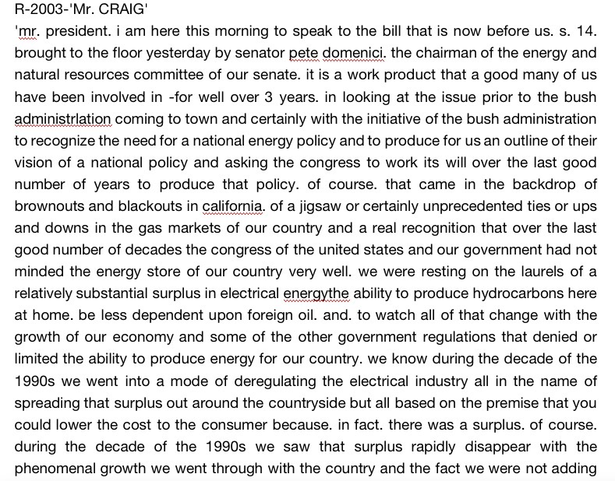

Figure 11: Figure 12:

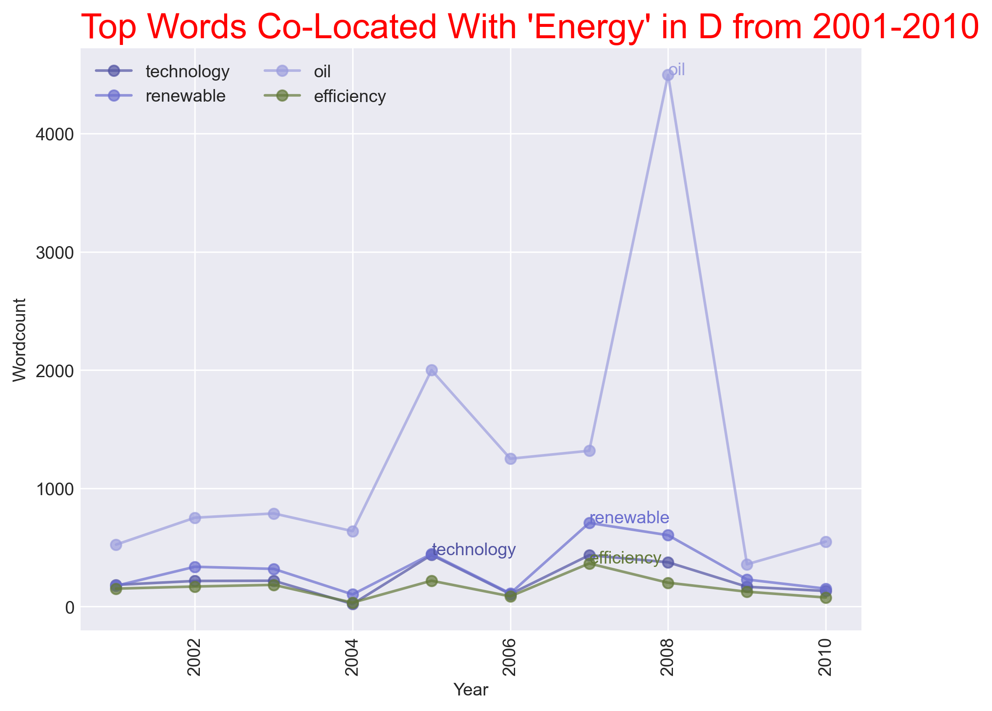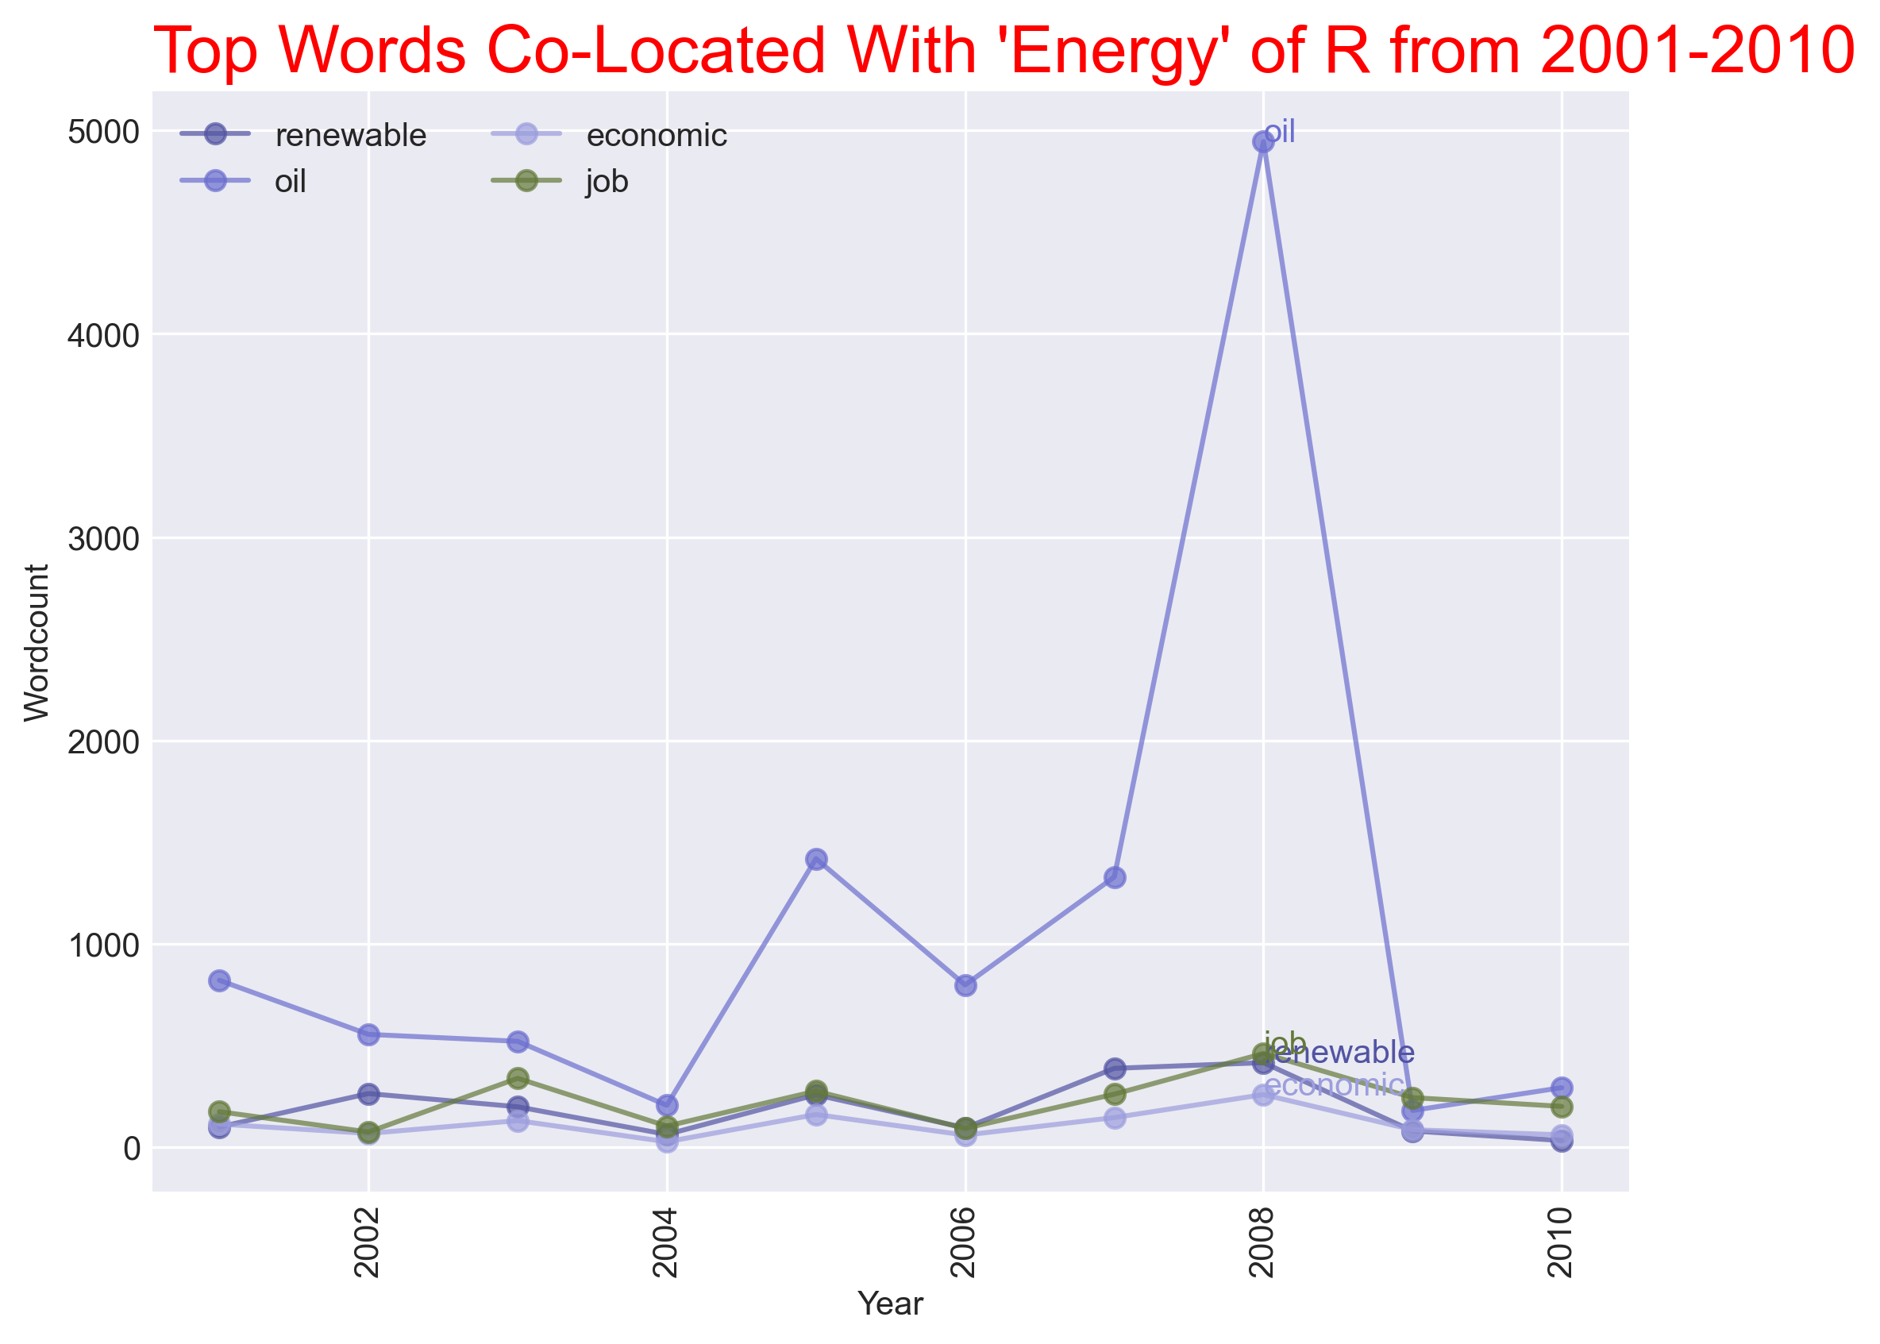

Work Cited

Allitt, P. (2015). *A climate of crisis : America in the age of environmentalism*. Penguin Books.

Luu, C. (2018, August 15). The Linguistics of Mass Persuasion: How Politicians Make “Fetch” Happen (Part I) | JSTOR Daily. JSTOR Daily. https://daily.jstor.org/the-linguistics-of-mass-persuasion-how-politicians-make-fetch-happen/

Mahalingam, A., Carpenter, O., Coburn, A., & Tuveson, M. (2018). US 2005 storms: Katrina, Rita, and Wilma - Disaster recovery case studies.

Taylor, J. B. (2009). The Financial Crisis and the Policy Responses: an Empirical Analysis of What Went Wrong. SSRN Electronic Journal. https://doi.org/10.2139/ssrn.1341170

‌

‌

‌